LAB-2
Task 9: Record All Tools, Documents, Commands, Screenshots and Observations

1. Tools Used:
Tool | Purpose
Docker Desktop | Container and image management
Docker Engine | Build and run containers
Docker Compose | Multi-container application
Docker Hub | Docker image registry
Kubernetes | Container orchestration
kubectl | Kubernetes cluster management
Git & GitHub | Source-code and CI/CD management
GitHub Actions | Continuous deployment

2. Project Files / Documents
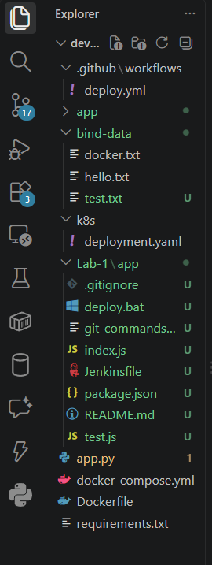
devops/
├── app.py
├── requirements.txt
├── Dockerfile
├── docker-compose.yml
├── bind-data/
├── k8s/
│ └── deployment.yaml
└── .github/
└── workflows/
└── deploy.yml

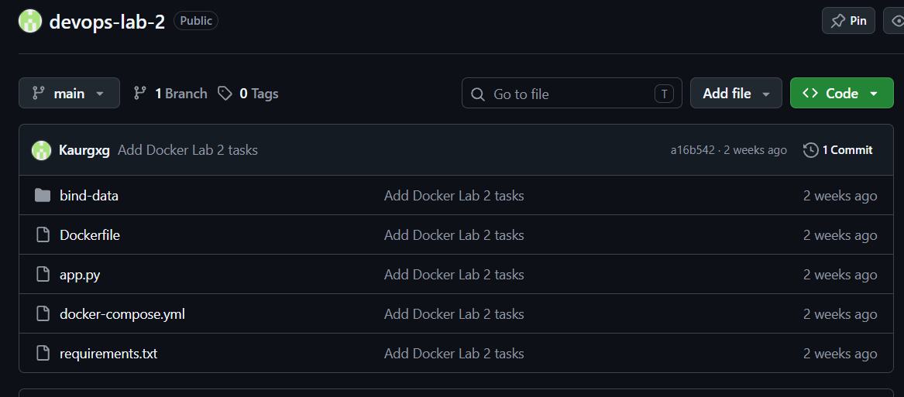
3. Github repository:

